**Lab 10**

**Name :-** Aryan Dilipbhai Langhanoja

**Date :-** 14-08-2023

**Enrollment No :-** 92200133030

**CO1: To write, test, and debug simple Python programs**

**CO2: To implement Python programs with conditional, loops and functions**

**Task 1:- Implementing the ndim functions**

**Python Code:**

a = np.array(0)

b = np.array([1,2,3])

c = np.array([[1,2,3],[4,5,6]])

d = np.array([[[1,2,3],[4,5,6]],[[1,2,3],[4,5,6]]])

e = np.array([[[[1,2],[3,4],[5,6]],[[1,2],[3,4],[5,6]]],[[[1,2],[3,4],[5,6]],[[1,2],[3,4],[5,6]]]])

print(d)

print(e)

print(a.ndim)

print(b.ndim)

print(c.ndim)

print(d.ndim)

print(e.ndim)

print("\n")

**Output:**

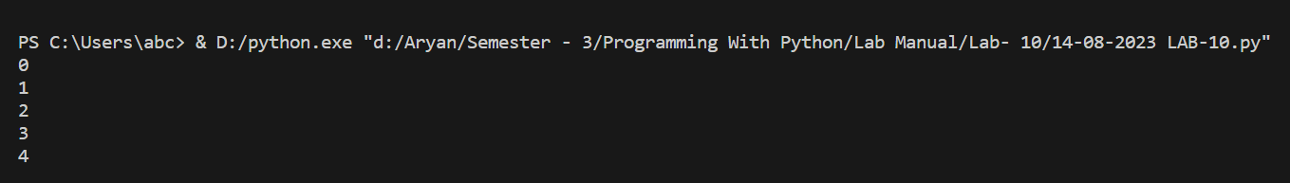

**Task 2:- Implementing the itemsize function**

**Python Code:**

d = np.array([[[1,2,3],[4,5,6]],[[1,2,3],[4,5,6]]])

print(d.itemsize)

**Output:**



**Task 3:- Implementing the dtype function**

**Python Code:**

a = np.array([[1,2.0],[3,4]])

print(a.dtype)

a = np.array([[1,2],[3,4+3j]])

print(a.dtype)

**Output:**

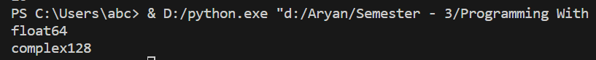

**Task 4:-** **Implementing Mean Functions**

**Python Code:**

a = np.array([[1,2],[3,4]])

b = np.mean(a,axis=0)

c = np.mean(a,axis=1)

print(a)

print(b)

print(c)

**Output:**

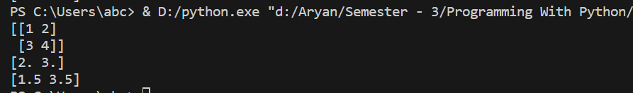

**Task 5:- Implementing Append Function**

**Python Code:**

a = np.array([[1,2],[3,4]])

b = np.array([[7,6],[8,9]])

c = np.append(a, b)

print(c)

**Output:**



**Task 6:- Implement Insert Function**

**Python Code:**

a = np.array([[1,2],[3,4],[5,6]])

print(np.insert(a, 2,[5,9],axis= 0))

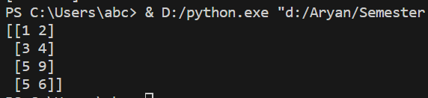**Output :**

**Task 7:- Arethematic Operation On Matrix**

**Python Code:**

x = np.array([[1,2],[3,4]],dtype = np.float64)

y = np.array([[5,6],[7,8]],dtype = np.float64)

print(x + y)

print(np.add(x,y))

print("\n")

print(x - y)

print(np.subtract(x,y))

print("\n")

print(x * y)

print(np.multiply(x,y))

print(np.dot(x, y))

print("\n")

print(x/y)

print(np.divide(x,y))

print("\n")

**Output:**

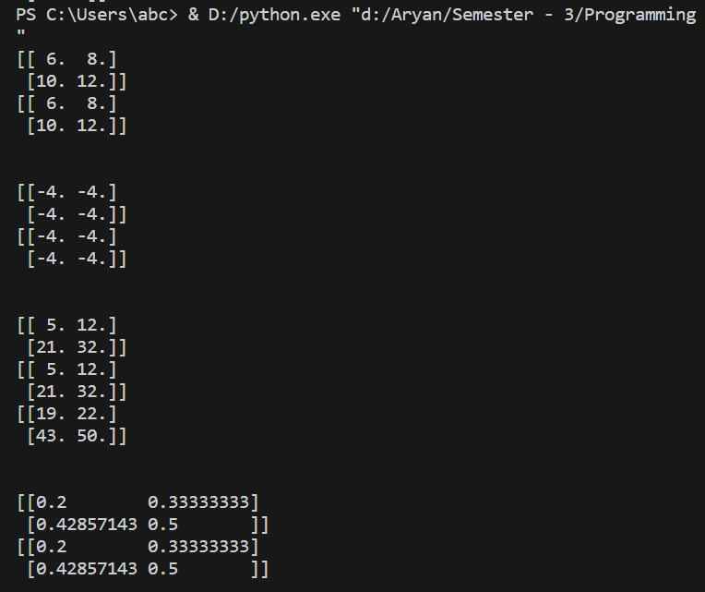

**Task 9:- Addition Of A Matrix**

**Python Code:**

arr1 = np.array([1,2,3])

arr2 = np.array([[1],[2],[3]])

sum = arr1 + arr2

print(sum)

**Output:**

